
HEALTH, SAFETY & ENVIRONMENT MANAGEMENT SYSTEM
DAN Construction Safety Manual (DCSM)
Heat Stress Control

Document Control
Document No. | 01-DAN-PRC-HSE-000016-HTSTRS | Revision | R01
Issue Date | June 2026 | Classification | Controlled — Internal
Document Owner | HSE Department | Page Format | US Letter
Approval
Prepared By | Reviewed By | Approved By
HSE Representative  Signature / Date | Competent Person (HSE)  Signature / Date | Project Director / Manager  Signature / Date

Table of Contents

1. Purpose
To establish specific guidelines and procedures for working in hot weather conditions, and to protect all personnel from heat-related illness during construction activities on DAN project sites.

2. Scope
This document applies to all CONTRACTOR and sub-contractor personnel undertaking work on DAN project sites where the potential for heat-related illness exists, including outdoor work, work in direct sunlight and work in enclosed or confined spaces with elevated temperatures.

3. References
- KSA Labour Law — prohibition of work under direct sunlight and in open areas from 15 June to 15 September between 12:00 and 15:00.
- DCSM — Activity Hazard Analysis (AHA).
- DCSM — SH&E Training.
- DCSM — First Aid.
- DCSM — Emergency Planning and Response.
- “Heat Stress: Improving Safety in the Arabian Gulf Oil and Gas Industry”, Professional Safety: Journal of the American Society of Safety Engineers, August 2008, pages 31–36.

4. Deliverables
- Heat Stress Management Plan.

5. Heat Stress Policy
Take all reasonable action to meet or exceed the applicable occupational health and safety requirements (domestic and international) for heat-stress management, and continuously monitor and improve operations, procedures, technologies and programmes beneficial to maintaining a safe and healthy working environment.
- Provide calibrated weather-monitoring equipment for the worksite.

6. Heat Stress Danger Categories
When the potential for heat-related illness exists, review the heat index (see tables below) periodically (e.g. every hour) at the worksite using the calibrated weather-monitoring equipment.
- The Heat Stress Danger Category, determined from the current heat index, must be declared at the job site when the potential for heat-related illness exists.
- The Heat Stress Danger Category must be used to determine control measures, including minimum resting times and drinking water needed.
- The current Heat Stress Danger Category and corresponding control measures must be communicated to personnel as conditions change (e.g. by colour-coded flags, information signs, or mass distribution of SMS text messages to site supervisors and other personnel).
Heat Stress Danger Categories
Danger Category | Heat Index | Heat Stress Illness / Symptoms | Work : Rest (min.) Periods | Minimum Water Needed*
IV — Extreme Danger | ≥ 52 | Heat stroke imminent. | 20 : 10 | 1 cup every 10 minutes
III — Danger | 39–51 | Heat cramps, heat exhaustion or heat stroke likely with prolonged exposure and physical activity. | 30 : 10 | 1 cup every 15 minutes
II — Extreme Caution | 30–38 | Heat cramps, heat exhaustion or heat stroke possible with prolonged exposure and physical activity. | 50 : 10 | 1 cup every 20 minutes
I — Caution | 25–29 | Fatigue possible with prolonged exposure and/or physical activity. | Normal / Scheduled | 1 cup every 20 minutes
Note: Heat-stress flag colours follow the heat-index table. The table is adapted from the August 2008 ASSE Professional Safety journal (see References).
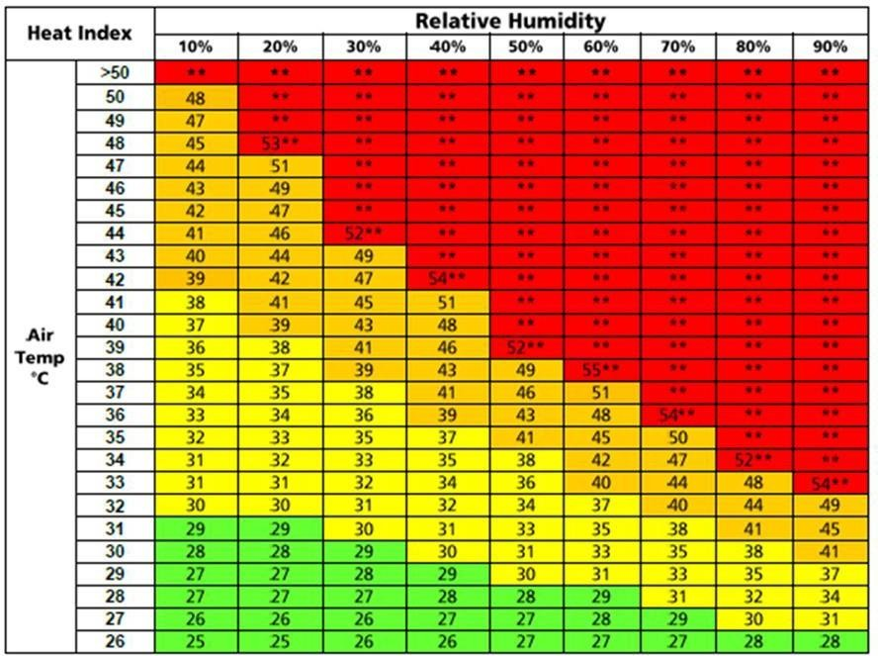
Figure 16-1 Heat and Humidity Index Table

7. Work Schedule
- Establish suitable work schedules during extreme hot weather to minimise exposure to conditions that could result in heat stress.
- Schedule the most strenuous work during the coolest times of the day (e.g. early morning and evening / night).
- Reschedule work planned to take place in direct sunlight to the coolest time of the day.
- Activities under direct sunlight and in open spaces from 15 June to 15 September between 12:00 and 15:00, and at any time when the temperature is ≥ 50 °C, are PROHIBITED (per KSA Labour Law) unless work must continue for technical reasons and an exemption from the Ministry is secured.

8. Special Considerations During Ramadan
- Appropriate planning and heat-stress mitigation measures must be incorporated into the specific work plan (e.g. Activity Hazard Analysis) for personnel who are fasting during Ramadan, if it occurs during the summer months.
- Supplies of cool drinking water must be available for personnel as needed during Ramadan (e.g. for personnel experiencing symptoms of a heat-related illness).

9. Site Management — Control of Heat Stress
During periods of high heat-stress potential (i.e. Danger Categories III or IV) at the worksite, the following measures must be implemented as applicable to control heat stress.
- Minimise work time in direct sunlight as much as possible.
Note: Lone work is PROHIBITED during periods of high heat stress (i.e. Danger Categories III or IV).
- Rotate personnel in and out of hot areas.
- Communicate and display in common areas of the site the designated break / recovery areas, emergency reporting procedures, and nearest medical facilities.
- Schedule work / rest rotations for personnel according to the current heat index (based on temperature and relative humidity in the Heat Index Table).
- Minimise high-intensity manual work (e.g. use mechanical / powered equipment to replace manual labour) as practical.
- Do not allow schedule or productivity demands to take priority over heat-stress awareness and the controls required to prevent heat-related illness.
- Conduct periodic (e.g. weekly) safety meetings / talks during hot weather to emphasise heat-stress hazards and essential precautions, with added emphasis during Ramadan if it occurs in summertime.
- Clearly display educational information on heat-stress conditions, illness / symptoms and preventive measures on bulletin boards and in break / recovery areas.
- Distribute heat-stress information at safety meetings / tool-box talks and other communications in a form suitable for personnel (e.g. laminated pocket cards).

9.1 Rehydration Aids / Supplements
- Provide rehydration supplements to all site staff.
- Before administering rehydration supplements, a medical evaluation to determine previous and pre-existing health conditions of a person must be carried out.

9.2 Ambient Temperature and Humidity Monitoring
- The working environment must be monitored for adverse weather conditions.
- Thermometers and hygrometers must be provided and strategically installed to effectively measure ambient temperature and humidity on site and in specific areas.
- Use the Heat and Humidity Index Table in this chapter to guide site staff on safe working conditions during hot weather.

9.3 Shade
- Designated shaded break / rest areas must be provided at a distance no greater than 100 m (330 ft) from personnel working in direct sunlight for extended periods.
- When feasible, provide shade for work areas, including single shades to accommodate flagmen, etc.

9.4 Local Ventilation
- When the air temperature is less than 37 °C (99 °F), fans or portable air movers may be used to reduce heat stress by increasing air flow in the work area.

9.5 Portable Air-Cooling Systems
- Portable blowers with built-in air chillers must be used as needed (e.g. when confined spaces and enclosed work areas have ambient temperatures exceeding 43 °C / 110 °F) to provide cooling for confined spaces and similar enclosed work areas.

10. Personal Protective Controls
A sunburn makes cooling body temperature much harder. UV radiation, whether from natural sunlight or artificial sources, can damage the eye's surface tissues as well as the cornea and lens, and can burn the front surface of the eye much like sunburn on the skin.

10.1 Sun Protection
- SUN BLOCK — protects the skin against the sun's rays.
- EYE PROTECTION — personnel must wear UV-protective safety eyewear.
Note: Sunscreen and UV-protective eyewear must be provided to personnel by the CONTRACTOR.

10.2 Ice-Cooling Garments
- Commercially available ice vests, neck / wrist wraps, etc. may be provided to personnel as needed (e.g. those who work for extended periods inside a confined space during hot weather).
- Ice packets must be replaced as required.

10.3 Clothing
When working in direct sunlight, light-coloured, lightweight, breathable clothing that covers as much of the body as possible — including the head — must be worn. In addition:
- Long sleeves are required.
- Short trousers are PROHIBITED.
- Synthetic fabrics increase heat stress. Appropriate planning and mitigation measures must be incorporated into the specific work plans (e.g. Activity Hazard Analysis) for personnel wearing synthetic clothing (e.g. polyester, nylon) while working in conditions with a high heat-stress potential.

10.4 Wetted Clothing / Towels
- During periods of high heat-stress potential, the CONTRACTOR must provide personnel with wetted terry-cloth towels and/or allow them to wet their normal work clothes as necessary to provide cooling for the body.
- Cool-water supplies (not ice water), separate from drinking water, must be used for this purpose (e.g. containers of clean water with a faucet / spigot for sanitary distribution, instead of dipping).

10.5 Acclimatisation
- Use deliberate acclimatisation to expose new personnel to work in a hot environment for progressively longer periods.
- New personnel in jobs where heat levels may produce heat stress must be introduced to 20 % of normal exposure on day one, with a 20 % increase in exposure each additional day.

10.6 Work / Rest Rotations
- Determine work and rest rotations based on the prevailing heat index at the worksite (see the Heat Stress Danger Categories and Heat Index tables in this chapter).
- Work rotations must be established for personnel (e.g. flagmen) performing remote activities in high heat-stress exposures.
- Personnel must be allowed additional break time and water as they deem necessary for their health.

10.7 Drinking Water
- Encourage personnel to drink plenty of water before the start of each shift.
- Ample supplies of cool drinking water must be available within 100 m (330 ft) walking distance of each person and in all designated break / rest areas.
- Personnel must drink small amounts of water frequently, based on the actual heat index at the worksite.
- Sports drinks, juices and electrolyte replacement / rehydration mixes may also be made available to help maintain the body's water and salt levels.
Note: Personnel may NOT consume more of these drinks than plain water. Personnel are prohibited from taking salt tablets due to potential adverse side-effects (e.g. nausea, vomiting and dehydration).

10.8 Personal Monitoring and Buddy System
- Personnel must work in pairs or teams and must observe each other for signs of diminished capacity and heat-related illness.
- Use regular check times and buddy-system controls to determine whether a person is experiencing diminished capacity or symptoms of heat stress.

11. Training / Awareness Campaigns
Ensure that all personnel know and understand the safety preparations and practices required during hot weather conditions. Communicate information about heat-stress prevention and emergency management to all personnel through safety bulletins, safety meetings, posters, video presentations, seminars and tool-box talks.

11.1 Heat Stress Awareness
- Heat-stress awareness training must be provided just before, and during, the hot summer months to all personnel who work outdoors, all management / supervisory personnel, and any personnel responsible for establishing heat-stress mitigation measures.
- Training must emphasise that heat stress can affect an individual's ability to reason clearly (which may cause a person to fail to recognise the signs and symptoms of heat stress).
Heat-related symptoms include:
- Headache, dizziness.
- Nausea, vomiting.
- Excessive sweating or dry skin.
- Fatigue, muscle cramps in the lower limbs.
- Visual disturbances or convulsions.
- Loss of consciousness.
Training must include (but is not limited to):
- Hazards of heat stress.
- Recognition of signs and symptoms of heat stress.
- First-aid procedures for heat stroke and other heat-related illnesses.
- Personnel's individual responsibilities in avoiding / responding to heat-related illness.
- Supervisor responsibilities in avoiding / responding to heat-related illness.
- Dangers of the use of prescription and over-the-counter medication in hot work environments.
- Measures individuals can take to minimise the effects of heat stress (e.g. hydration, work pace, use of wet towels, good nutritional habits).
- Personal monitoring and buddy-system controls.
Note: “Check times” are intervals at which a heat-stress-trained supervisor or observer (including a co-worker or “buddy”) checks for obvious symptoms of heat-related illness or any sense of diminished capacity in individuals and/or co-workers. Self-monitoring must be supplemented by scheduled check times and buddy-system controls.

11.2 First Aid / Emergency Responders
- Provide special training (and refresher training) in the recognition and treatment of heat-related illnesses to first-aid and emergency responders.

12. Heat Disorder Emergency Procedures
- For all incidents of heat-related illness, emergency contact numbers must be posted at the worksite where they are visible and easily accessible to all personnel.

12.1 Recovery
- Any employee experiencing symptoms of a heat-related illness must immediately stop work and report to their supervisor.
- The victim must be allowed to fully recover in an appropriate recovery area before returning to work.
- Recovery areas must be shaded, cool and supplied with water.

12.2 Steps Before the Medic or Ambulance Arrives
- Victims of severe heat exhaustion or heat stroke must be immediately evacuated to the nearest medical facility with qualified medical staff who can provide proper treatment. While awaiting help:
- Transfer the victim to a shady area and place them in a lying position with feet slightly raised.
- Use a fan and cover the victim with cold packs or a cold wet towel.
- Give fluids if the person is conscious.

13. Documentation
- The records custodian documents all instruction and training.
- The SH&E Representative maintains the records at site for the duration of the project and archives them at project close.

Revision History
Rev. | Date | Description of Change | Approved By
R00 | June 2026 | Initial issue. Restructured to the DAN integrated HSSE management-system template and re-branded in accordance with the DAN Brand Book. | Project Director
R01 | June 2026 | Re-coded to the updated DAN document-numbering convention (01-DAN-PRC-HSE-{seq}{code}). | Project Director

